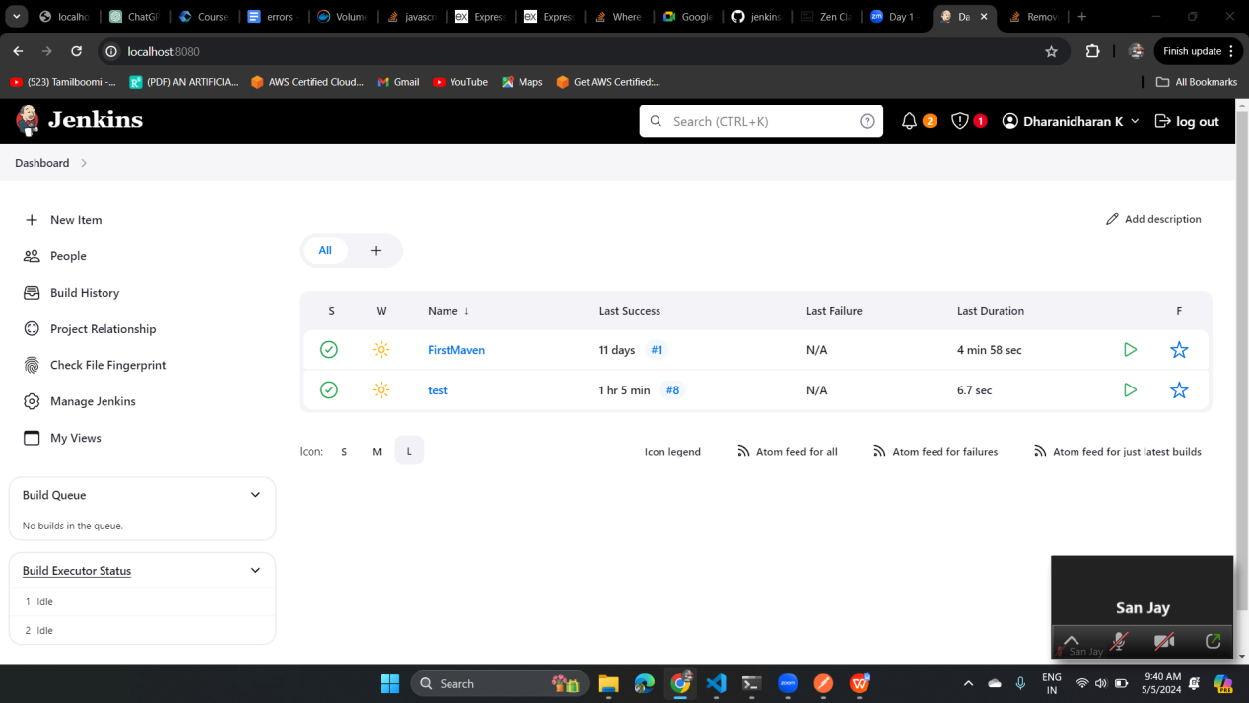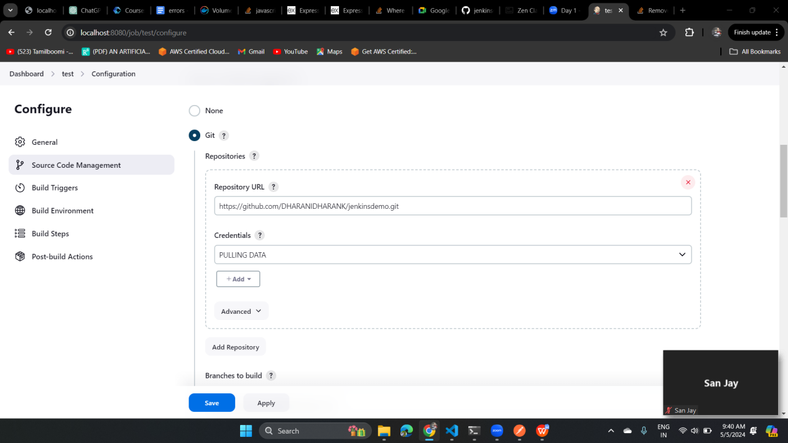

The below image is executing the build for every two minutes   
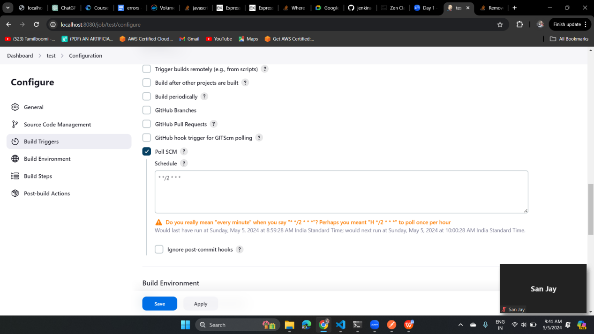

delete workspace before build is cleaning up the workspace because if we run some build for twice having making directory means it will throw. So by enabling this can clear the workspace before a each build   
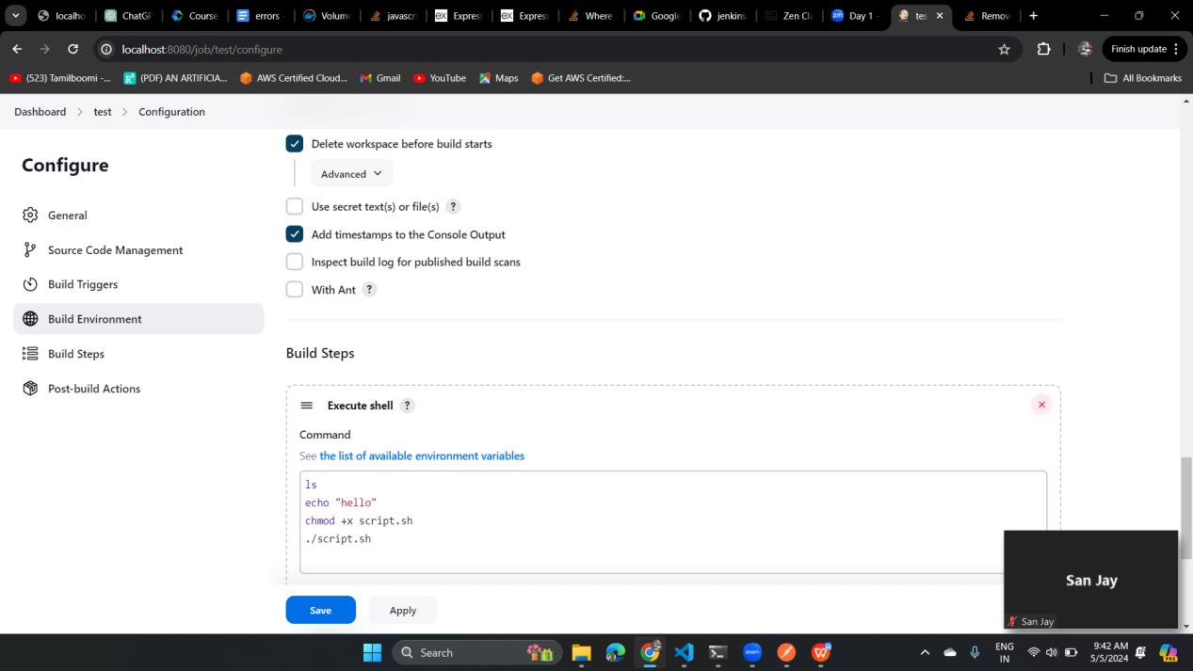

Build trigger is like hitting the token generated from the authenticate token section with the token when we hit it in the browser the build will run   
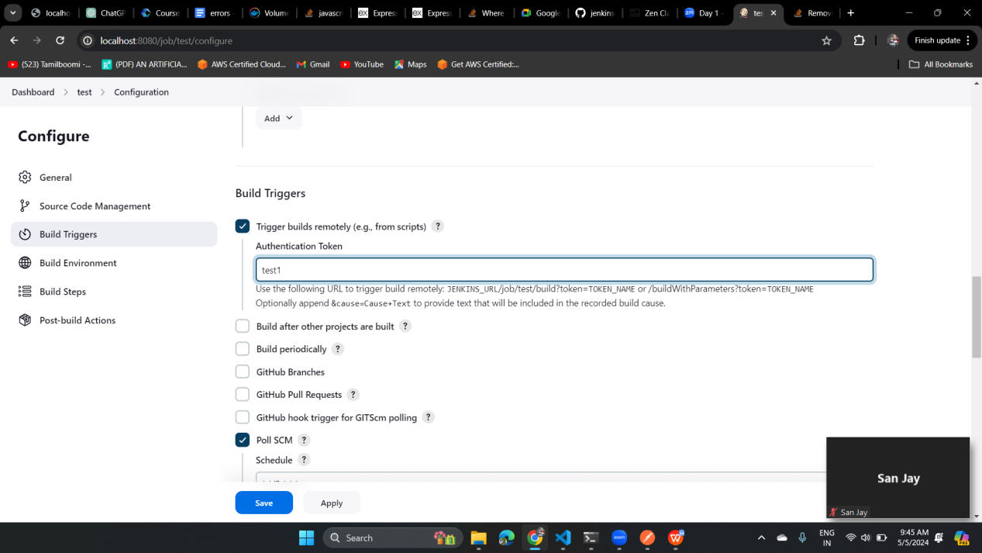

Hitting with the token from the browser   


Build created result

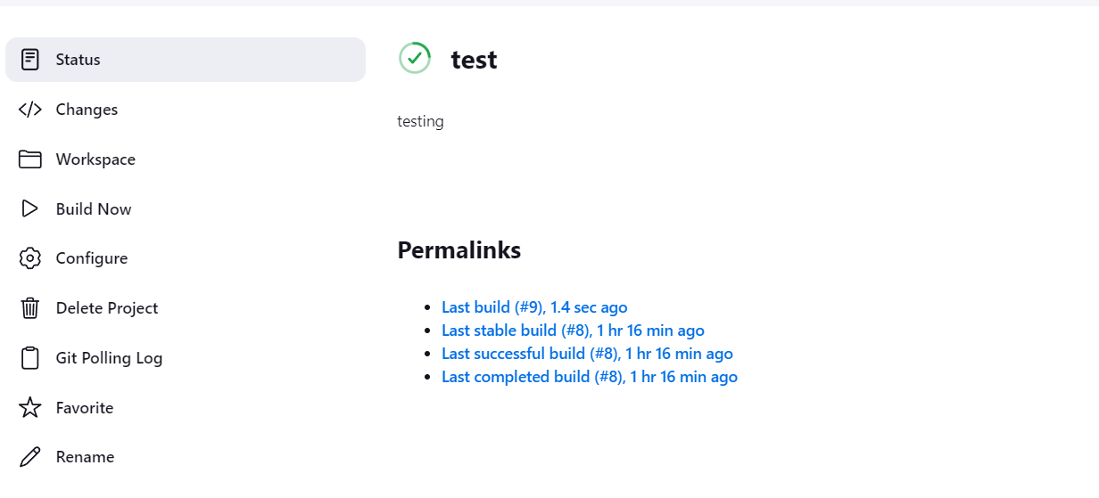

Discarding old build :  
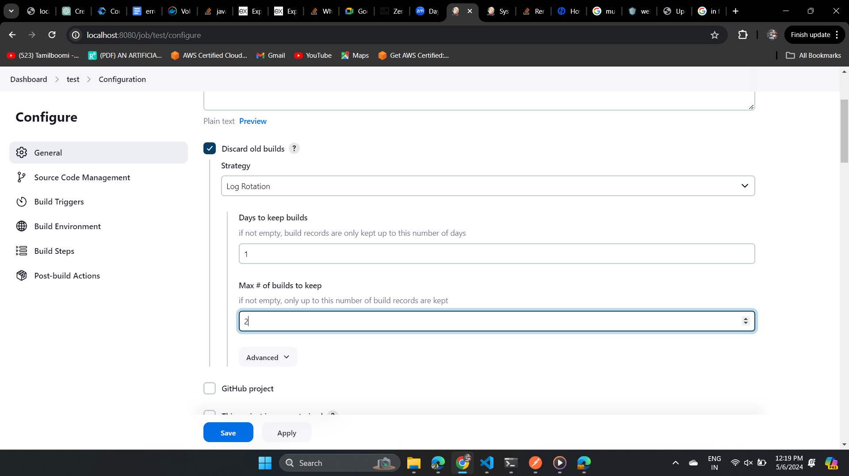

Output for the discard old build the rest of the build have been deleted :  
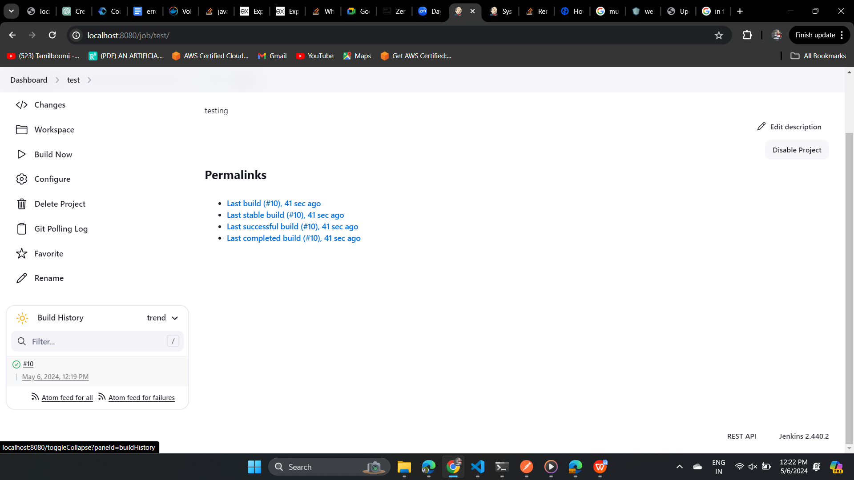  
  
Assign role to the user where we have created to access the project based on the matrix authentication  
